Inventory

management system for Retailers

TeamId: PNT2022TMID26359

TEAm mEmBERs

Chandramouli-211719104027

Harish-211719104040

Jagadeep-211719104048

DhanushKV -211719104032

Bhavana-211719104030

# INTRODUCTION

Retail inventory management is the process of ensuring you carry merchandise that shoppers want, with neither too little nor too much on hand. By managing inventory, retailers meet customer demand without running out of stock or carrying excess supply.

* 1. **PROJECT OVERVIEW**

In practice, eﬀective retail inventory management results in lower costs and a better understanding of sales patterns. Retail inventory management tools and methods give retailers more information on which to run their businesses. Retailers can access their accounts by logging into the application.

Once retailers successfully log in to the application they can update their inventory details, also users will be able to add new stock by submitting essential details related to the stock.

## PURPOSE

Retail inventory management works by creating systems to log products, receive them into inventory, track changes when sales occur, manage the flow of goods from purchasing to final sale and check stock counts.

Inventory management helps companies identify which and how much stock to order at what time. It tracks inventory from purchase to the sale of goods. The practice identifies and responds to trends to ensure there's always enough stock to fulfill customer orders and proper warning of a shortage.

# LITERATURE SURVEY

* 1. Retailer Inventory strategy based on system Dynamics

simulation

System dynamics (SD) was created during the mid-1950s by Professor Jay Forrester of the Massachusetts Institute of Technology.

The supply chain inventory management aims at meeting customers' demands, reducing inventory cost and increasing enterprise profit. We need place an order and replenish productions when the inventory is under safety stock quantity.

## DISADVANTAGE:

One of the disadvantages of this methodology is the development of the system dynamics model of complex systems since an extensive study has to be carried out, so that this system works correctly in the system dynamics model, and not on the contrary, affect the project where the dynamics of the system is being carried out.

## REFERENCES:

1. A. Sapietova and V. Dek ´ y`s, “Dynamic analysis of rotating machines in ˇ msc. adams,” Procedia Engineering, vol. 136, no. 143-149, p. 12, 2016.
2. T. Rebs, M. Brandenburg, and S. Seuring, “System dynamics modeling for sustainable supply chain management: A literature review and systems thinking approach,” Journal of cleaner production, vol. 208, pp. 1265–1280, 2019.

## PROBLEM STATEMENT:

In inventory systems, demand is usually uncertain, and the lead-time can also vary. To avoid shortages, managers often maintain a safety stock. In such situations, it is not clear what order quantities and reorder points will minimize expected total inventory cost. Simulation models can address this question.

# IDEATION & PROPOSED SOLUTION

## EMPATHY MAP CANVAS:

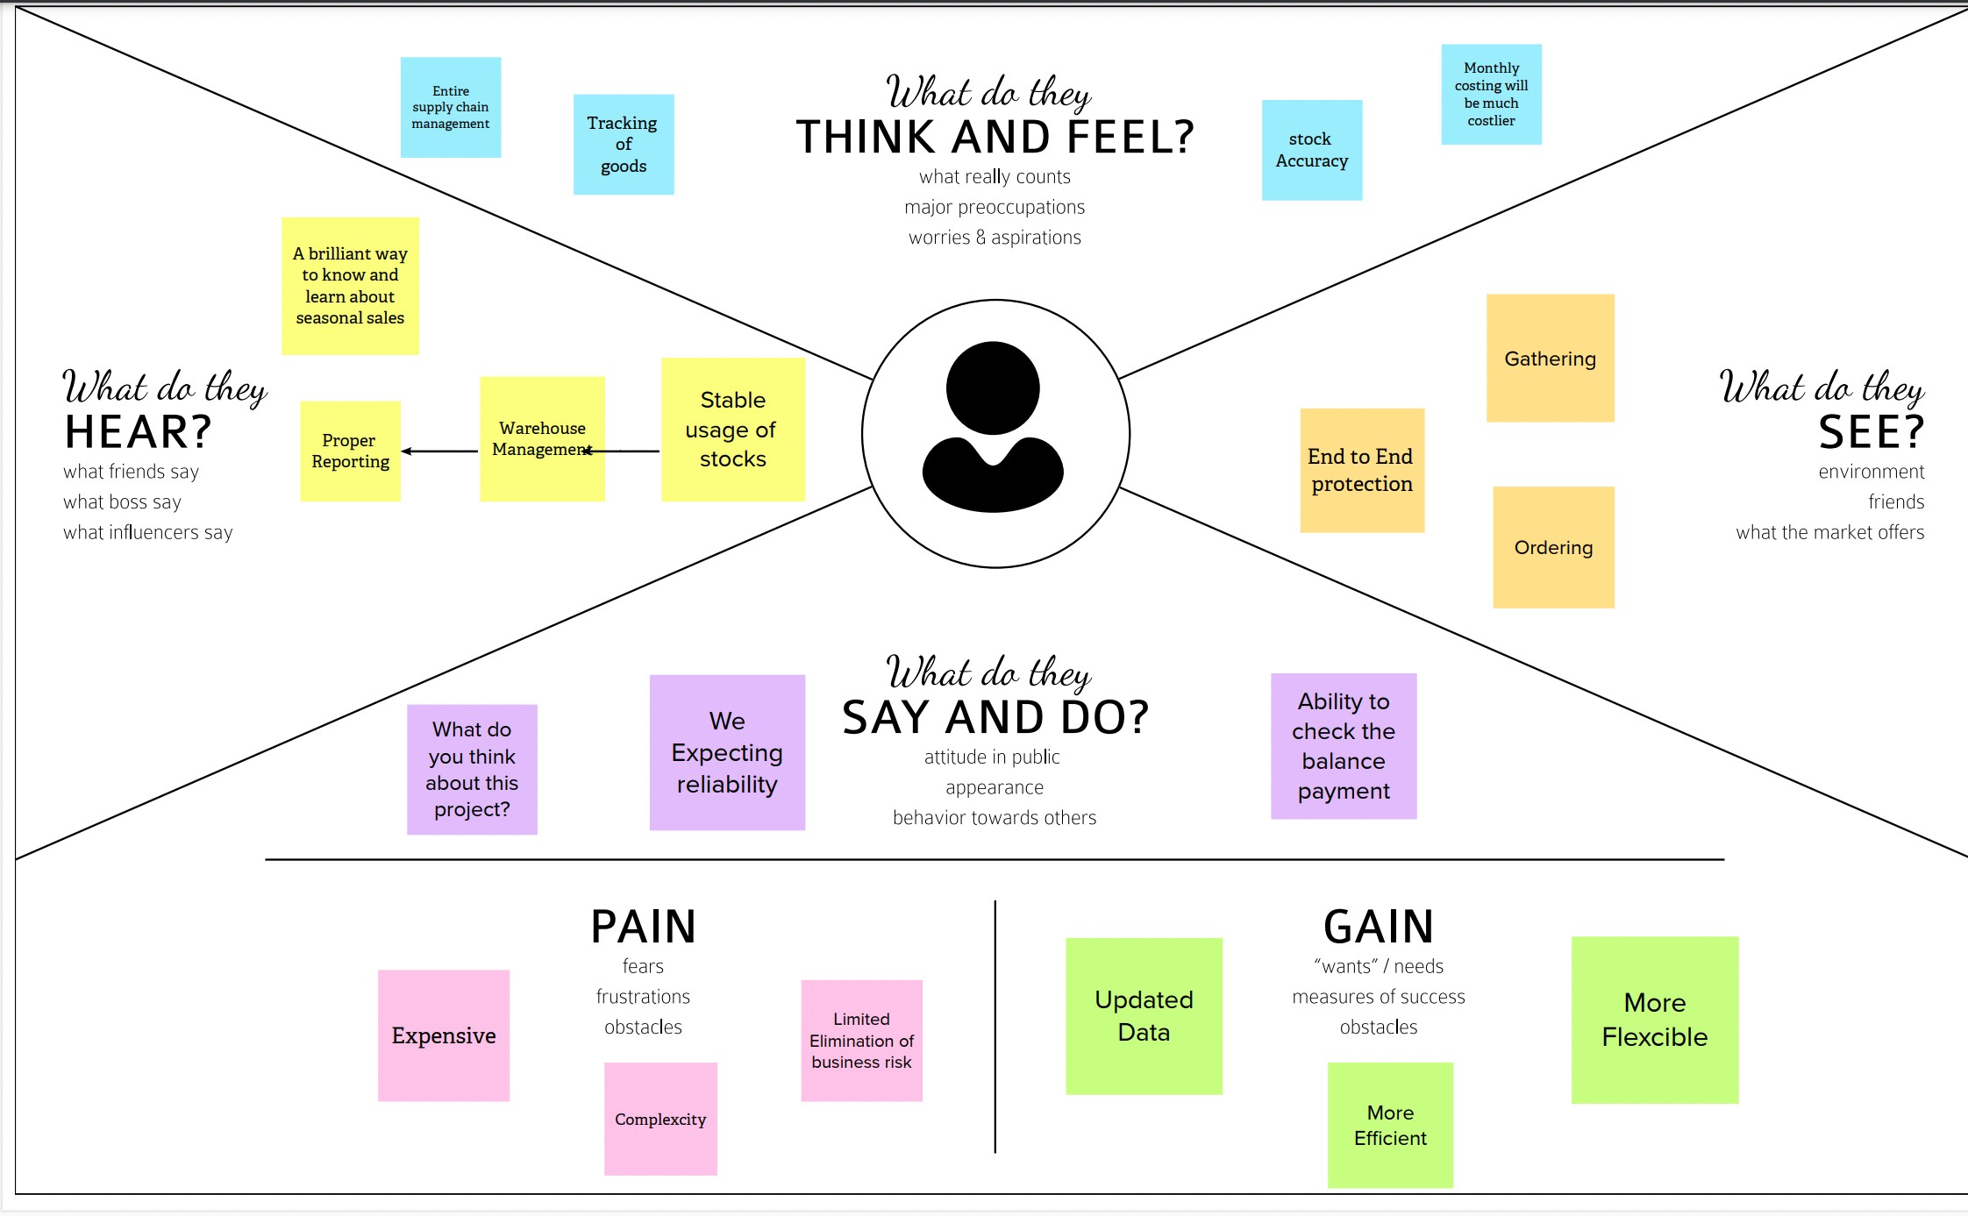

* 1. 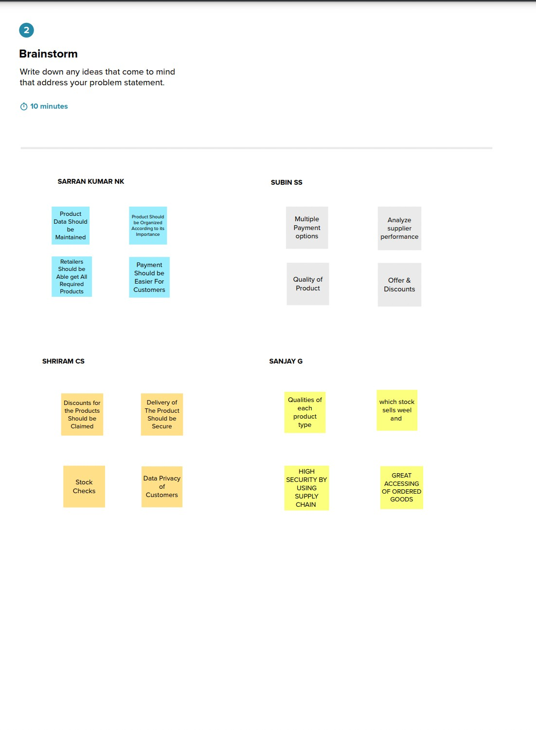**BRAINSTORMING:**

4

## PROPOSED SOLUTION:

Problem Statement (Problem to be solved) • The retailers generally facing issues in recording the stocks and its threshold limit available.

* Idea / Solution description • This proposed system will have a daily update system whenever a product is sold or it is renewed. • The product availability is tracked daily and an alert system in again kept on to indicate those products which falls below the threshold limit. • The application allows the customers to know all the present time available stocks and also when the new stock will be available on the store for them to buy.
* Novelty / Uniqueness • Certain machine learning algorithms are used to predict the seasonal high selling products which can be made available during that time. • Prediction of the good selling brand of all certain products based on their popularity, price and customer trust and satisfaction will be implemented. • Notifications will be sent to the retailers if any product that the customers have been looking for is not available.
* Social Impact / Customer Satisfaction • The customers will be highly satisfied since the wastage of time while searching for an unavailable product is reduced.

## PROBLEM SOLUTION FIT:

1. CUSTOMER SEGMENTION(S) - ➢ It is an important marketing tool. ➢ Customer segmentation helps the enterprises increase profit and improve customer service level.
2. CONSTRAINTS - ➢ Constraints include limits on ➢ Raw Materials ➢ Machine Capacity

* Work force capacity ➢ Inventory Investment ➢ Storage Space

1. CHALLENGES - ➢ Inconsistent Tracking ➢ Warehouse Eﬃciency ➢ Inaccurate Data ➢ Changing Demand ➢ Limited Visibility ➢ Manual Documentation ➢ Problem Stock ➢ Insuﬃcient Order Management
2. PROBLEM ROOT CAUSE - ➢ Visibility Problems ➢ Lack of real-time reporting ➢

Ineﬃciency ➢ Under Stocking ➢ Over Stocking ➢ Lack of trend forecasting

1. YOUR SOLUTION - • Developing a database in that database if the product is in out of stock sending a SMS alerting message • provide a option for graphical view ofsales
2. CHANNELS of BEHAVIOUR -1. ONLINE • Alerting the particular person about the stocks limits, either full or empty or even about the reach of a particular limit
3. OFFLINE • Manual Checking • Stock Distribution among the Inventory
   1. REQUIREmEnT AnALYsIs

### Functional Requirements:

FR-1 Account Creation Created through Email Creation through Github Creation through LinkedIn Creation via Google

FR-2 User Confirmation Confirmation via Email FR-3 Successful Log in Notification through Email

FR-4 Update inventory details Notification through Email FR-5 Add new stock Notification through Email

FR-6 Unavailability of stock Alert notification through Email

### NON - FUNCTIONAL RREQUIREMENTS:

NFR-1 Usability - When the account is created in the application , all the details about the stock has to be filled. And when the stocks are no more left the application will get to know this and does the process.

NFR-2 Security - The Application has a very good security , because not everyone can access the application. Only the employees who have the access can only access the application. The Application requires Authentication. Because of this no one can misuse this application.

NFR-3 Performance - The products can be tracked by the users. The tracking can enhance the timed deliveries. With the help of this the man power can also be reduced. Emails will be delivered automatically when there is shortage of products.

NFR-4 Availability - Inventory management systems are designed to monitor product availability, determine purchasing schedules for better customer interaction.

NFR-5 Scalability - Scalability is an aspect or rather a functional quality of a system, software or solution. This proposed system for inventory management system can accommodate expansion without restricting the existing workflow and ensure an increase in the output or efficiency of the process.

## PROJECT DESIGN

* 1. **DATA FLOW DIAGRAM:**

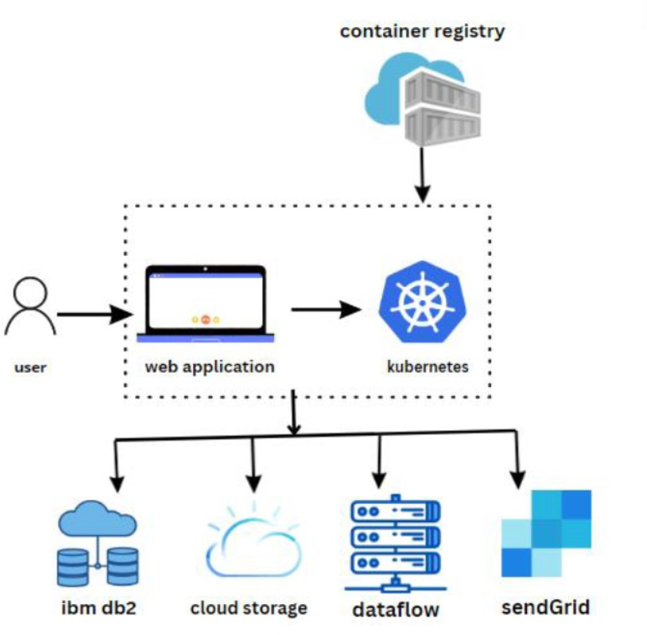

## SOLUTION & TECHNICAL ARCHITECTURE:

* 1. **USER STORIES:**

***Customer (Mobile user) Registration***

***USN-1*** As a user, I can register for the application by entering my email, password, and confirming my password. I can access my account / dashboard High Sprint-1 ***USN-2*** As a user, I will receive confirmation email once I have registered for the application I can receive confirmation email & click confirm High Sprint-1

***USN-3*** As a user, I can register for the application through Facebook I can register & access the dashboard with Facebook Login Low Sprint-2

***USN-4*** As a user, I can register for the application through Gmail I can receive confirmation email & click confirm Medium Sprint-1

Login

***USN-5*** As a user, I can log into the application by entering email & password I can enter into my account High Sprint-1

Dashboard

***USN-6*** As a user, it displays all top brands and offersof product I can avail the recent offerin sale High Sprint-2 Customer (Web user)

Application

***USN-7*** As a user, I can register, login and shop the products easily I can access my shopping very soon High Sprint-3 Customer Care Executive

Update Inventory details

***USN-8*** To keep track of order and availability of stockin inventory I can control the inventory stock correctly High Sprint-4 Administrator

Add new stock

***USN-9*** To add new products into the application I can provide new trend products in an application for customer needs High Sprint-3 Customer Care Executive

Verify customer feedback

***USN-10*** To design application that meets user’s desires I can satisfy the customer expectations High Sprint-4 Customer Care Executive

Inventory Control

***USN-11*** To refill the unavailability of stock in inventory I can alert notification through email Medium Sprint-2 Administrator

Performance of Application

***USN-12*** To make the business process more efficient I can save time, cost to fulfil orders by improving the inventory management High Sprint-4

## PROJECT PLANNING & SCHEDULING

* 1. 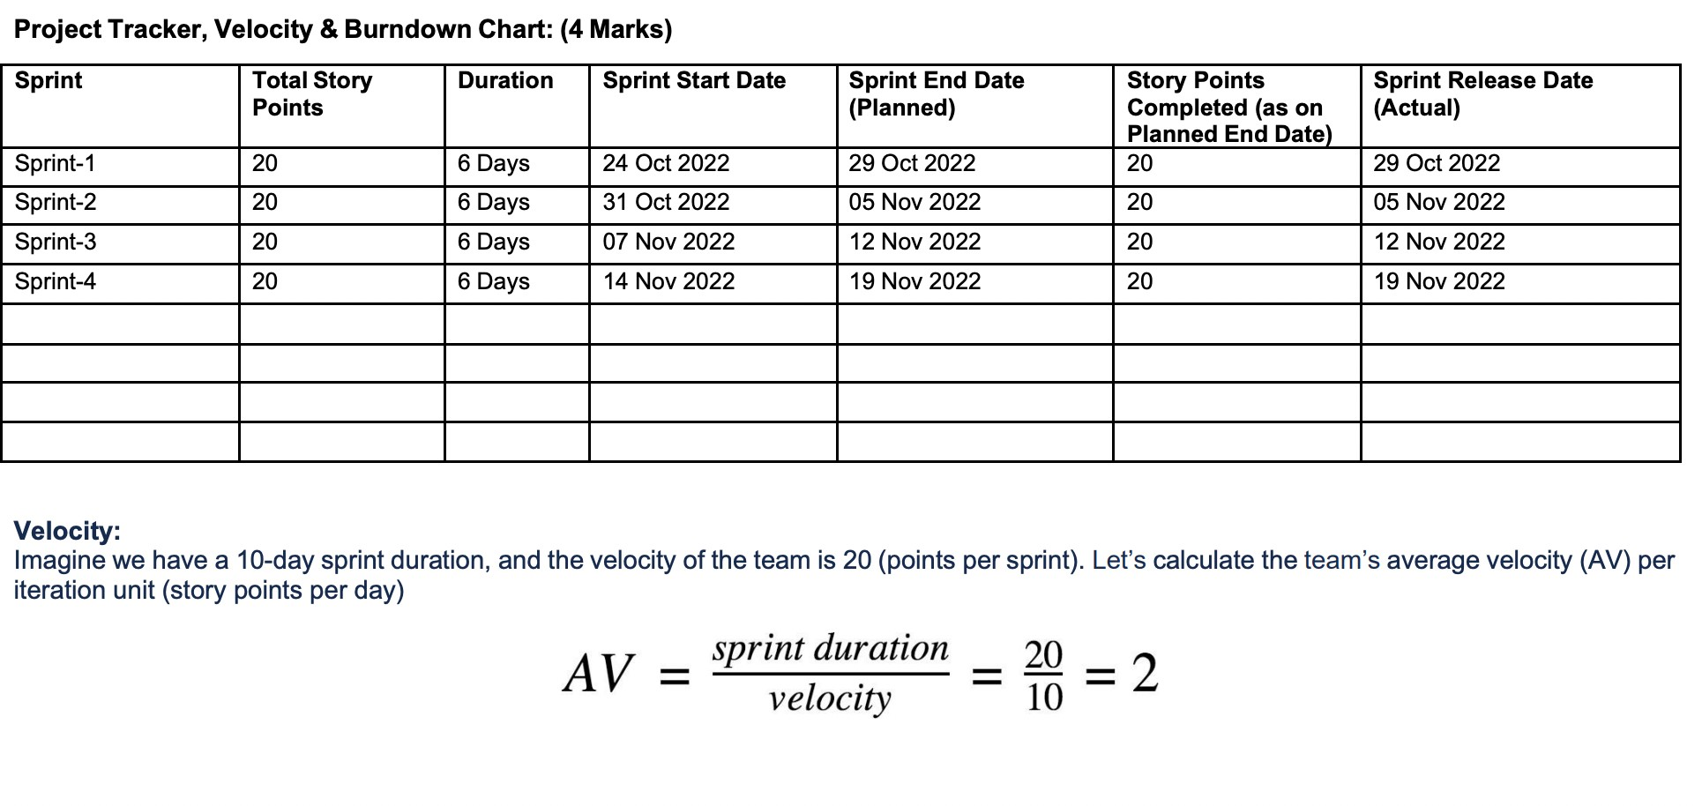**SPRINT PLANNAING & ESTIMATION**

## SPRINT DELIVERY SCHEDULE:

* 1. **CODING & SOLUTIONING:**

## FEATURE 1:

**Optimizing Your Inventory**

You want to maintain the right amount of inventory required to meet demand, keep logistics costs low, and avoid common inventory issues such as stock outs, overstocking, and backorders.

### Inventory Forecasting

A company has a 30-day forecast for cookies. If they sold 43 units over the previous 30 days, the base demand would be 43.

It gives a starting point to show you how you can increase accuracy. You can gather trends like these from your data that may influence demand.

### Demand Planning

A grocery store wants to prepare its inventory levels for next year at the end of Thanksgiving. They look at sales, competition, and growth. They can now plan and launch new deals to position themselves as the go-to Thanksgiving destination.

Your inventory may need different optimization and planning. For example, you ordered the exact amount of raw materials. Later on, with variation in supply, you wish you had extra safety stock.

## FEATURE 2: Security and Backup

You have to make sure that your inventory is safe to be in control of stored goods. You need security for warehouse management as safety and efficiency lead to good performance. To help keep operations running smoothly, ensure you address supply chain and inventory control strategies and have backup plans in place before there is an issue.

## RESULTS:

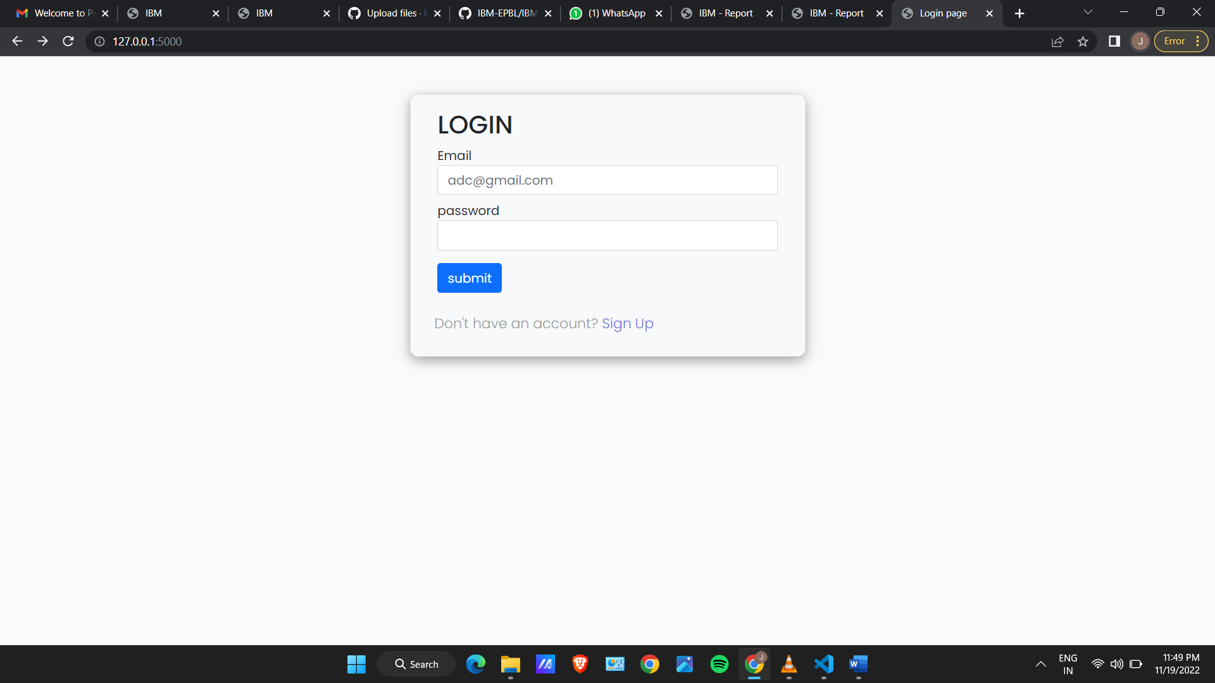

It has been implemented successfully and Executed.

## ADVANTAGES & DISADVANTAGES:

ADVANTAGES:

**Saves Time** - Paper-based retail inventory management can take a lot of time and effort.

**Eliminates Errors** - Traditional retail inventory processes can be vulnerable to errors.

**Improves Transparency** - In the retail industry, the visibility of the real-time status of the various items in the inventory is very critical.

**Cost-Effective** - Manual inventory control would increase your labor and process costs.

**Efficient Stock Counting** - If done manually, stock counting is a tedious and error-prone process.

DISADVANTAGES:

**Production problem:** even though inventory management can reveal to you the amount of stock you have at hand and the amount that you have sold oﬀ, it can also hide production problems that could lead to customer service disasters.

**Complexity:** some methods and strategies of inventory management can be relatively complex and diﬃcult to understand on the part of the staﬀ.

**High implementation costs:** some inventory management systems can come at a high price because the business needs to install specialized systems and software in order to use them.

**Bureaucracy:** even though inventory management allows employees at every level of the company to read and manipulate company stock and product inventory, the infrastructure required to build such a system adds a layer of bureaucracy to the whole process and the business in general.

The control of inventory is complex because of the many functions it performs. It should thus be viewed as a shared responsibility.

## CONCLUSION

The project inventory management for retailers has been successfully implemented by using python, flask, html / css / java script and the database created by using ibm db2 and also successfully executed and implemented.

## FUTURE SCOPE

The scope of an inventory system can cover many needs, including valuing the inventory, measuring the change in inventory and planning for future inventory levels. The value of the inventory at the end of each period provides a basis for financial reporting on the balance sheet. Measuring the change in inventory allows the company to determine the cost of inventory sold during the period. This allows the company to plan for future inventory needs.

1. **APPENDIX**

# SOURCE CODE:

<!DOCTYPE html>

<html lang="en">

<head>

  <meta charset="utf-8" />

  <meta name="viewport" content="width=device-width, initial-scale=1" />

  <link href="https://cdn.jsdelivr.net/npm/bootstrap@5.0.2/dist/css/bootstrap.min.css" rel="stylesheet"

    integrity="sha384-EVSTQN3/azprG1Anm3QDgpJLIm9Nao0Yz1ztcQTwFspd3yD65VohhpuuCOmLASjC" crossorigin="anonymous" />

  <link rel="stylesheet" href="static/css/style.css" />

  <script src="https://cdn.jsdelivr.net/npm/bootstrap@5.0.2/dist/js/bootstrap.bundle.min.js"

    integrity="sha384-MrcW6ZMFYlzcLA8Nl+NtUVF0sA7MsXsP1UyJoMp4YLEuNSfAP+JcXn/tWtIaxVXM"

    crossorigin="anonymous"></script>

  <!-- <link rel="stylesheet" href="{{url_for('static', filename='css/style.css')}}"> -->

  {% block head%}{% endblock %}

</head>

<body>

  <div class="container mt-5">{% block body %} {% endblock %}</div>

</body>

<main class="container ">

    <div class="mx-auto mt-5 border bg-light login-card " style="width:500px;">

        <h2 class='mx-4 mt-2'>LOGIN</h2>

        <form action="{{url_for('login') }}" method="post">

            <div class="mx-4 mt-2 text-danger">{{ msg }}</div>

            <div class="my-2 mx-4">

                <label for="username">Email</label>

                <input type="text" class="form-control" placeholder="adc@gmail.com" name="username" required />

            </div>

            <div class="my-2 mx-4">

                <label for="password_1">password</label>

                <input type="password" class="form-control" name="password_1" required />

            </div>

            <input type="submit" value="submit" class="btn btn-primary my-4 mt-2 mx-4" />

        </form>

        <p>Don't have an account?<a href="{{ url_for('signup') }}"> Sign Up</a>

    </div>

</main>

**GitHub**

**& Project**

**Demo**

**Link:**

**GitHub - https://github.com/IBM-EPBL/IBM-Project-22745-1659857563**

**Project Demo Link -** https://drive.google.com/file/d/12xACbSHd710X60r6hYJ11LJMr4RqI1pW/view?usp=drivesdk